Chapter 10. Extending Your Shop

In the previous chapter, you learned how to integrate a payment gateway into your shop. You also learned how to generate CSV and PDF files.

In this chapter, you will add a coupon system to your shop and create a product recommendation engine.
This chapter will cover the following points:

- Creating a coupon system
- Applying coupons to the shopping cart
- Applying coupons to orders
- Creating coupons for Stripe Checkout
- Storing products that are usually bought together
- Building a product recommendation engine with Redis

Functional overview
Figure 10.1 shows a representation of the views, templates, and functionalities that will be built in this chapter:
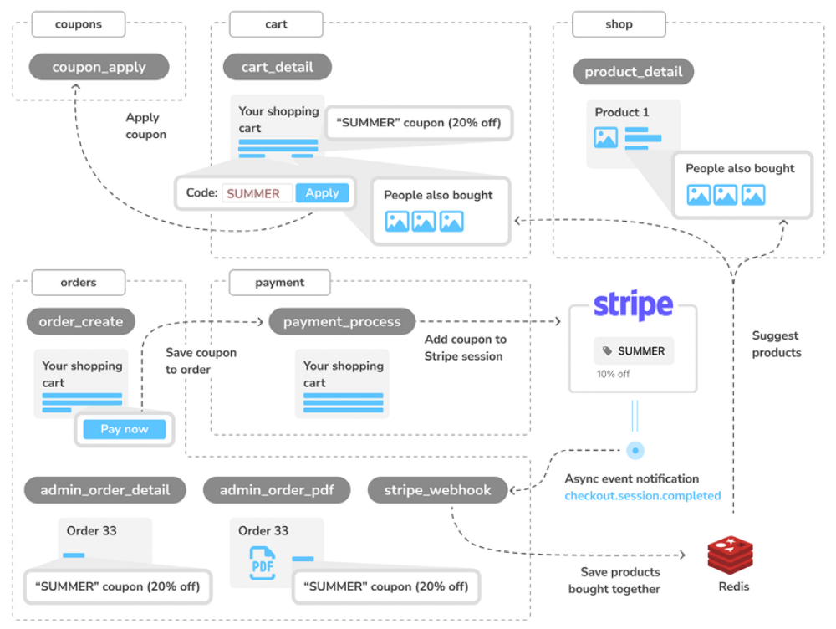
Figure 10.1: Diagram of functionalities built in Chapter 10

In this chapter, you will build a new coupons application and create the coupon_apply view to apply discount coupons to the cart session. You will add the discount applied to the template of the cart_detail view of the cart application. When an order is created with the order_create view of the orders application, you will save the coupon to the order created. Then, when you create the Stripe session in the payment_process view of the payment application, you will add the coupon to the Stripe checkout session before redirecting the user to Stripe to complete the payment. You will add the discount applied to the templates of the admin views admin_order_detail and admin_order_pdf of the order application. In
addition to the coupon system, you will also implement a recommendation system. When the checkout.session.completed Stripe event is received by the stripe_webhook view, you will save the products that have been bought together in Redis. You will add product recommendations to the product_detail and cart_detail views by retrieving from Redis the items that are frequently bought together.
The source code for this chapter can be found at
https://github.com/PacktPublishing/Django-5-byexample/tree/main/Chapter10.
All the Python packages used in this chapter are included in the requirements.txt file in the source code for the chapter. You can follow the instructions to install each Python package in the following sections, or you can install all the requirements at once with the command python -m pip install -r requirements.txt .

Creating a coupon system
Many online shops give out coupons to customers that can be redeemed for discounts on their purchases. An online coupon usually consists of a code that is given to users and is valid for a specific time frame.

You are going to create a coupon system for your shop. Your coupons will be valid for customers during a certain time frame. The coupons will not have any limitations in terms of the number of times they can be redeemed, and they will be applied to the total value of the shopping cart.

For this functionality, you will need to create a model to store the coupon code, a valid time frame, and the discount to apply.

Create a new application inside the myshop project using the following command:
python manage.py startapp coupons

Edit the settings.py file of myshop and add the application to the
INSTALLED_APPS setting, as follows:
INSTALLED_APPS = [
# ...
'coupons.apps.CouponsConfig',
]

The new application is now active in your Django project.

Building the coupon model
Let’s start by creating the Coupon model. Edit the models.py file of the coupons application and add the following code to it:
from django.core.validators import MaxValueValidator, MinValueVa
from django.db import models
class Coupon(models.Model):
code = models.CharField(max_length=50, unique=True)
valid_from = models.DateTimeField()
valid_to = models.DateTimeField()
discount = models.IntegerField(
validators=[MinValueValidator(0), MaxValueValidator(100)
help_text='Percentage value (0 to 100)'
)
active = models.BooleanField()
def __str__(self):
return self.code

This is the model that you are going to use to store coupons. The Couponmodel contains the following fields:

- code : The code that users have to enter in order to apply the coupon to their purchase.

- valid_from : The datetime value that indicates when the coupon becomes valid.

- valid_to : The datetime value that indicates when the coupon becomes invalid.

- discount : The discount rate to apply (this is a percentage, so it takes values from 0 to 100 ). You use validators for this field to limit the minimum and maximum accepted values.

- active : A Boolean that indicates whether the coupon is active.

Run the following command to generate the initial migration for the coupons application:
python manage.py makemigrations

The output should include the following lines:
Migrations for 'coupons':
coupons/migrations/0001_initial.py
- Create model Coupon

Then, execute the next command to apply migrations:
python manage.py migrate

You should see an output that includes the following line:
Applying coupons.0001_initial... OK

The migrations have now been applied to the database. Let’s add the Coupon model to the administration site. Edit the admin.py file of the coupons application and add the following code to it:
from django.contrib import admin
from .models import Coupon
@admin.register(Coupon)
class CouponAdmin(admin.ModelAdmin):
list_display = [
'code',
'valid_from',
'valid_to',
'discount',
'active'
]
list_filter = ['active', 'valid_from', 'valid_to']
search_fields = ['code']

The Coupon model is now registered on the administration site. Ensure that your local server is running with the following command:
python manage.py runserver

Open http://127.0.0.1:8000/admin/coupons/coupon/add/ in your browser.
You should see the following form:
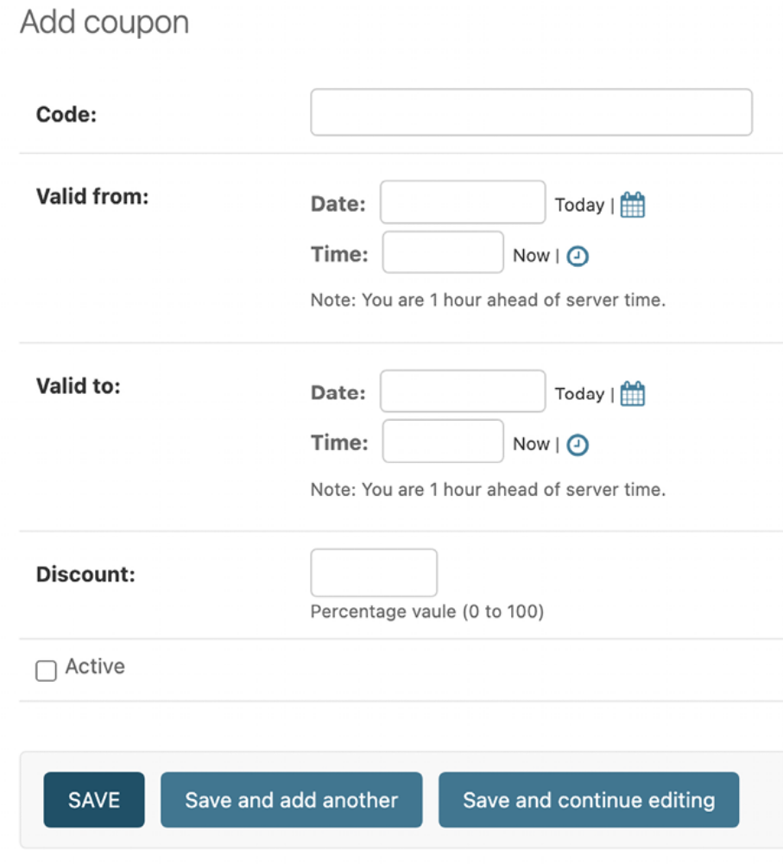
Figure 10.2: The Add coupon form on the Django administration site

Fill in the form to create a new coupon that is valid for the current date.
Make sure that you check the Active checkbox, and click the SAVE button. Figure 10.3 shows an example of creating a coupon:
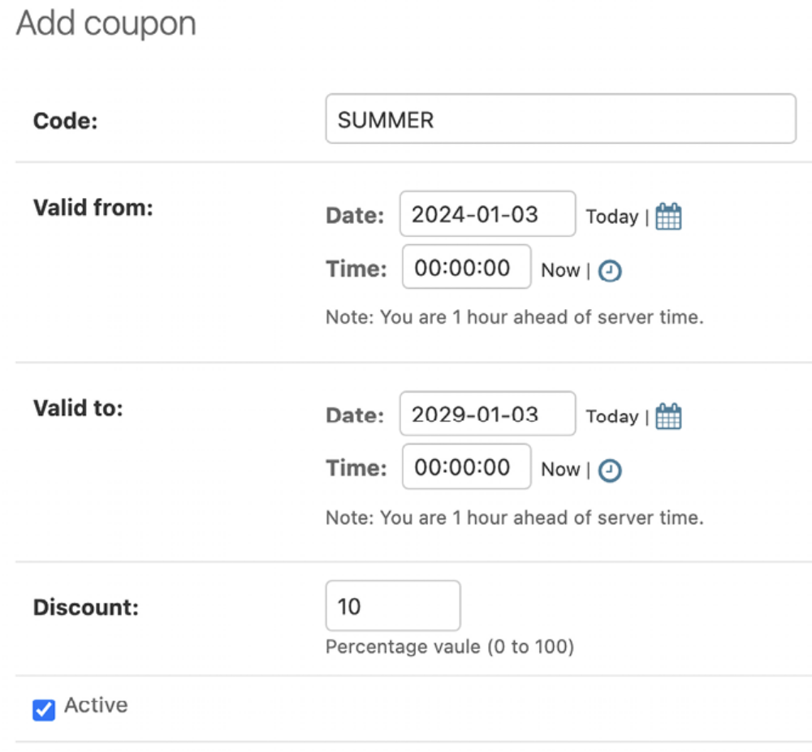
Figure 10.3: The Add coupon form with sample data

After creating the coupon, the coupon change list page on the administration site will look similar to Figure 10.4:
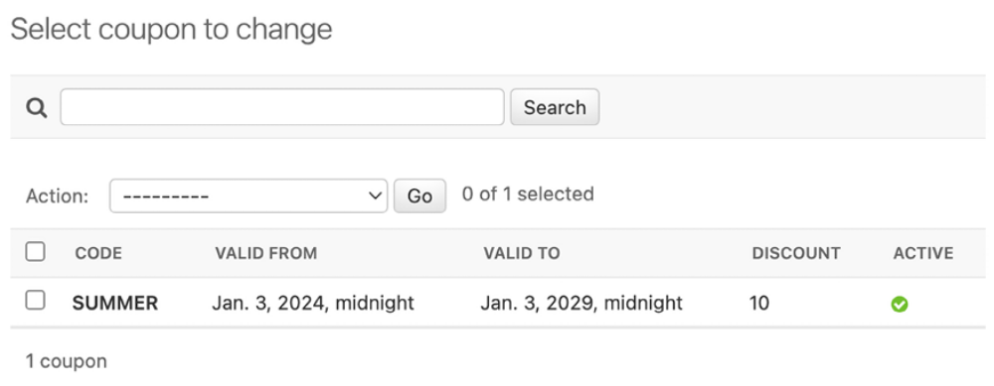
Figure 10.4: The coupon change list page on the Django administration site
Next, we will implement the functionality to apply coupons to the shopping cart.

Applying a coupon to the shopping cart
You can store new coupons and make queries to retrieve existing coupons.
Now you need a way for customers to apply coupons to their purchases. The functionality to apply a coupon would be as follows:

- The user adds products to the shopping cart.

- The user can enter a coupon code in a form displayed on the shopping cart details page.

- When the user enters a coupon code and submits the form, you look for an existing coupon with the given code that is currently valid. You have to check that the coupon code matches the one entered by the user, that the active attribute is True , and that the current datetime is between the valid_from and valid_to values.

- If a coupon is found, you save it in the user’s session and display the cart, including the discount applied to it and the updated total amount.

- When the user places an order, you save the coupon to the given order.

Create a new file inside the coupons application directory and name it forms.py .
Add the following code to it:
from django import forms
class CouponApplyForm(forms.Form):
code = forms.CharField()

This is the form that you are going to use for the user to enter a coupon code.
Edit the views.py file inside the coupons application and add the following code to it:
from django.shortcuts import redirect
from django.utils import timezone
from django.views.decorators.http import require_POST
from .forms import CouponApplyForm
from .models import Coupon
@require_POST
def coupon_apply(request):
now = timezone.now()
form = CouponApplyForm(request.POST)
if form.is_valid():
code = form.cleaned_data['code']
try:
coupon = Coupon.objects.get(
code__iexact=code,
valid_from__lte=now,
valid_to__gte=now,
active=True
)
request.session['coupon_id'] = coupon.id
except Coupon.DoesNotExist:
request.session['coupon_id'] = None
return redirect('cart:cart_detail')

The coupon_apply view validates the coupon and stores it in the user’s session. You apply the require_POST decorator to this view to restrict it to POST requests. In the view, you perform the following tasks:

1. You instantiate the CouponApplyForm form using the posted data and check that the form is valid.

2. If the form is valid, you get the code entered by the user from the form’s cleaned_data dictionary. You try to retrieve the Coupon object with the given code. You use the iexact field lookup to perform a caseinsensitive exact match. The coupon has to be currently active (active=True ) and valid for the current datetime. You use Django’s timezone.now() function to get the current timezone-aware datetime, and you compare it with the valid_from and valid_to fields by performing the lte (less than or equal to) and gte (greater than or equal to) field lookups, respectively.

3. You store the coupon ID in the user’s session.

4. You redirect the user to the cart_detail URL to display the cart with the coupon applied.

You need a URL pattern for the coupon_apply view. Create a new file inside the coupons application directory and name it urls.py . Add the following code to it:
from django.urls import path
from . import views
app_name = 'coupons'
urlpatterns = [
path('apply/', views.coupon_apply, name='apply'),
]
Then, edit the main urls.py of the myshop project and include the coupons
URL patterns with the following line highlighted in bold:
urlpatterns = [
path('admin/', admin.site.urls),
path('cart/', include('cart.urls', namespace='cart')),
path('orders/', include('orders.urls', namespace='orders')),
path('payment/', include('payment.urls', namespace='payment'
path('coupons/', include('coupons.urls', namespace='coupons'
path('', include('shop.urls', namespace='shop')),
]

Remember to place this pattern before the shop.urls pattern. Now, edit the cart.py file of the cart application. Include the following import:
from coupons.models import Coupon

Add the following code highlighted in bold to the end of the __init__() method of the Cart class to initialize the coupon from the current session:
class Cart:
def __init__(self, request):
"""
Initialize the cart.
"""
self.session = request.session
cart = self.session.get(settings.CART_SESSION_ID)
if not cart:
# save an empty cart in the session
cart = self.session[settings.CART_SESSION_ID] = {}
self.cart = cart
# store current applied coupon
self.coupon_id = self.session.get('coupon_id')

In this code, you try to get the coupon_id session key from the current session and store its value in the Cart object. Add the following methods highlighted in bold to the Cart object:
class Cart:
# ...
@property
def coupon(self):
if self.coupon_id:
try:
return Coupon.objects.get(id=self.coupon_id)
except Coupon.DoesNotExist:
pass
return None
def get_discount(self):
if self.coupon:
return (
self.coupon.discount / Decimal(100)
) * self.get_total_price()
return Decimal(0)
def get_total_price_after_discount(self):
return self.get_total_price() - self.get_discount()

These methods are as follows:

- coupon() : You define this method as a property . If the cart contains a

- coupon_id attribute, the Coupon object with the given ID is returned. get_discount() : If the cart contains a coupon, you retrieve its discount rate and return the amount to be deducted from the total amount of the cart.

- get_total_price_after_discount() : You return the total amount of the cart after deducting the amount returned by the get_discount() method.

The Cart class is now prepared to handle a coupon applied to the current session and apply the corresponding discount.

Let’s include the coupon system in the cart’s detail view. Edit the views.py file of the cart application and add the following import to the top of the file:
from coupons.forms import CouponApplyForm

Further down, edit the cart_detail view and add the new form to it, as follows:
def cart_detail(request):
cart = Cart(request)
for item in cart:
item['update_quantity_form'] = CartAddProductForm(
initial={'quantity': item['quantity'], 'override': T
)
coupon_apply_form = CouponApplyForm()
return render(
request,
'cart/detail.html',
{
'cart': cart,
'coupon_apply_form': coupon_apply_form
}
)

Edit the cart/detail.html template of the cart application and locate the following lines:
<tr class="total">
<td>Total</td>
<td colspan="4"></td>
<td class="num">${{ cart.get_total_price }}</td>
</tr>

Replace them with the following code:
{% if cart.coupon %}
<tr class="subtotal">
<td>Subtotal</td>
<td colspan="4"></td>
<td class="num">${{ cart.get_total_price|floatformat:2 }}</td>
</tr>
<tr>
<td>
"{{ cart.coupon.code }}" coupon
({{ cart.coupon.discount }}% off)
</td>
<td colspan="4"></td>
<td class="num neg">
- ${{ cart.get_discount|floatformat:2 }}
</td>
</tr>
{% endif %}
<tr class="total">
<td>Total</td>
<td colspan="4"></td>
<td class="num">
${{ cart.get_total_price_after_discount|floatformat:2 }}
</td>
</tr>

This is the code for displaying an optional coupon and its discount rate. If the cart contains a coupon, you display the first row, including the total amount of the cart as the subtotal. Then, you use a second row to display the current coupon applied to the cart. Finally, you display the total price, including any discount, by calling the get_total_price_after_discount() method of the cart object.
In the same file, include the following code after the </table> HTML tag:
<p>Apply a coupon:</p>
<form action="{% url "coupons:apply" %}" method="post">
{{ coupon_apply_form }}
<input type="submit" value="Apply">
{% csrf_token %}
</form>

This will display the form to enter a coupon code and apply it to the currentcart.
Open http://127.0.0.1:8000/ in your browser and add a product to the cart. You will see that the shopping cart page now includes a form to apply a coupon:
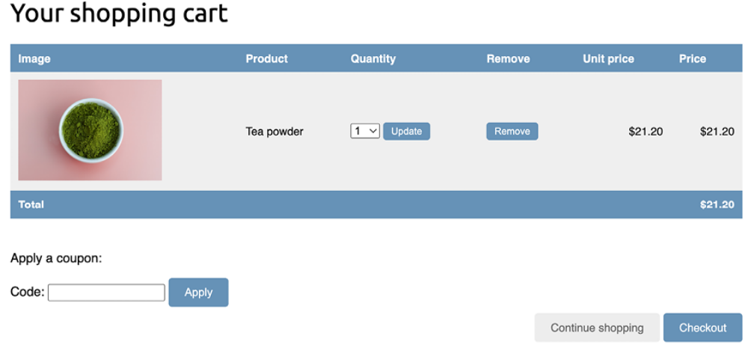
Figure 10.5: The cart detail page, including a form to apply a coupon


Image of Tea powder: Photo by Phuong Nguyen on Unsplash

In the Code field, enter the coupon code you created using the administration site:
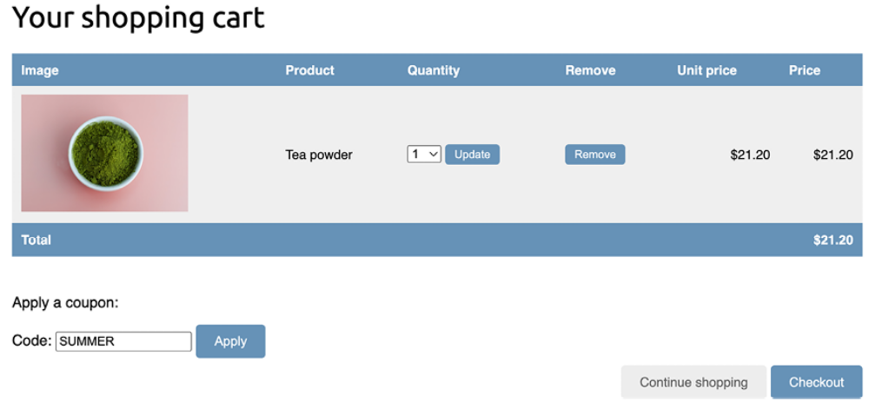
Figure 10.6: The cart detail page, including a coupon code on the form

Click the Apply button. The coupon will be applied, and the cart will display the coupon discount as follows:
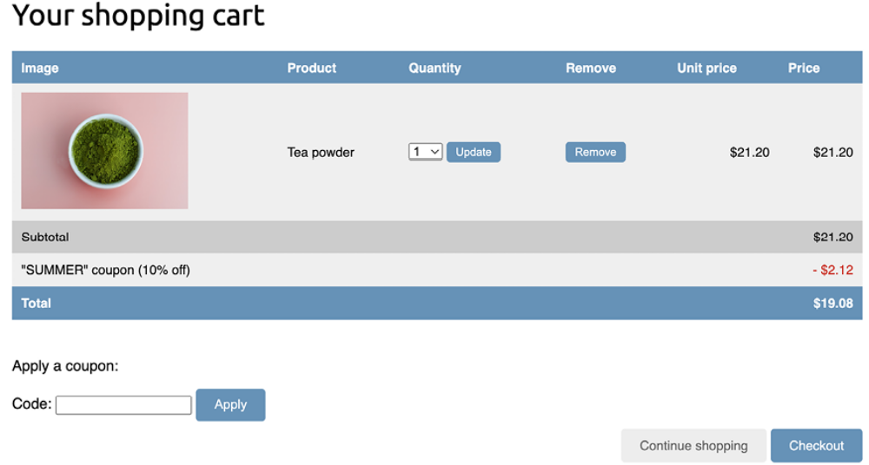
Figure 10.7: The cart detail page, including the coupon applied

Let’s add the coupon to the next step of the purchase process. Edit the orders/order/create.html template of the orders application and locate the following lines:
<ul>
{% for item in cart %}
<li>
{{ item.quantity }}x {{ item.product.name }}
<span>${{ item.total_price }}</span>
</li>
{% endfor %}
</ul>

Replace them with the following code:
<ul>
{% for item in cart %}
<li>
{{ item.quantity }}x {{ item.product.name }}
<span>${{ item.total_price|floatformat:2 }}</span>
</li>
{% endfor %}
{% if cart.coupon %}
<li>
"{{ cart.coupon.code }}" ({{ cart.coupon.discount }}% off)
<span class="neg">- ${{ cart.get_discount|floatformat:2 }}</spa
</li>
{% endif %}
</ul>

The order summary should now include the coupon applied, if there is one. Now find the following line:
<p>Total: ${{ cart.get_total_price }}</p>

Replace it with the following:
<p>Total: ${{ cart.get_total_price_after_discount|floatformat:2

By doing this, the total price will also be calculated by applying the discount of the coupon.
Open http://127.0.0.1:8000/orders/create/ in your browser. You should see that the order summary includes the applied coupon, as follows:
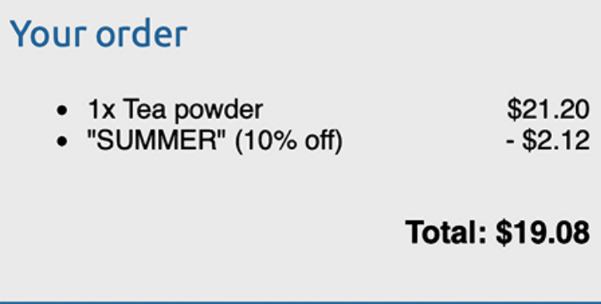
Figure 10.8: The order summary, including the coupon applied to the cart

Users can now apply coupons to their shopping carts. However, you still need to store coupon information in the order that it is created when users check out the cart.

Applying coupons to orders
You are going to store the coupon that was applied to each order. First, you need to modify the Order model to store the related Coupon object, if there is one.

Edit the models.py file of the orders application and add the following imports to it:
from decimal import Decimal
from django.core.validators import MaxValueValidator, MinValueVa
from coupons.models import Coupon

Then, add the following fields to the Order model:
class Order(models.Model):
# ...
coupon = models.ForeignKey(
Coupon,
related_name='orders',
null=True,
blank=True,
on_delete=models.SET_NULL
)
discount = models.IntegerField(
default=0,
validators=[MinValueValidator(0), MaxValueValidator(100)
)

These fields allow you to store an optional coupon for the order and the discount percentage applied with the coupon. The discount is stored in the related Coupon object, but you can include it in the Order model to preserve it if the coupon has been modified or deleted. You set on_delete to models.SET_NULL so that if the coupon gets deleted, the coupon field is set to Null , but the discount is preserved.

You need to create a migration to include the new fields of the Order model.
Run the following command from the command line:
python manage.py makemigrations

You should see an output like the following:
Migrations for 'orders':
orders/migrations/0003_order_coupon_order_discount.py
- Add field coupon to order
- Add field discount to order

Apply the new migration with the following command:
python manage.py migrate orders

You should see the following confirmation indicating that the new migration has been applied:
Applying orders.0003_order_coupon_order_discount... OK

The Order model field changes are now synced with the database.
Edit the models.py file, and add two new methods, get_total_cost_before_discount() and get_discount(), to the Order model like this. The new code is highlighted in bold:
class Order(models.Model):
# ...
def get_total_cost_before_discount(self):
return sum(item.get_cost() for item in self.items.all())
def get_discount(self):
total_cost = self.get_total_cost_before_discount()
if self.discount:
return total_cost * (self.discount / Decimal(100))
return Decimal(0)

Then, edit the get_total_cost() method of the Order model as follows. The new code is highlighted in bold:
def get_total_cost(self):
total_cost = self.get_total_cost_before_discount()
return total_cost - self.get_discount()
The get_total_cost() method of the Order model will now take into account the discount applied, if there is one.

Edit the views.py file of the orders application and modify the order_create view to save the related coupon and its discount when creating a new order. Add the following code highlighted in bold to the
order_create view:
def order_create(request):
cart = Cart(request)
if request.method == 'POST':
form = OrderCreateForm(request.POST)
if form.is_valid():
order = form.save(commit=False)
if cart.coupon:
order.coupon = cart.coupon
order.discount = cart.coupon.discount
order.save()
for item in cart:
OrderItem.objects.create(
order=order,
product=item['product'],
price=item['price'],
quantity=item['quantity']
)
# clear the cart
cart.clear()
# launch asynchronous task
order_created.delay(order.id)
# set the order in the session
request.session['order_id'] = order.id
# redirect for payment
return redirect('payment:process')
else:
form = OrderCreateForm()
return render(
request,
'orders/order/create.html',
{'cart': cart, 'form': form}
)

In the new code, you create an Order object using the save() method of the OrderCreateForm form. You avoid saving it to the database yet by using commit=False . If the cart contains a coupon, you store the related coupon and the discount that was applied. Then, you save the order object to the database.

Edit the payment/process.html template of the payment application and locate the following lines:
<tr class="total">
<td>Total</td>
<td colspan="4"></td>
<td class="num">${{ order.get_total_cost }}</td>
</tr>

Replace them with the following code. New lines are highlighted in bold:
{% if order.coupon %}
<tr class="subtotal">
<td>Subtotal</td>
<td colspan="3"></td>
<td class="num">
${{ order.get_total_cost_before_discount|floatformat:2 }}
</td>
</tr>
<tr>
<td>
"{{ order.coupon.code }}" coupon
({{ order.discount }}% off)
</td>
<td colspan="3"></td>
<td class="num neg">
- ${{ order.get_discount|floatformat:2 }}
</td>
</tr>
{% endif %}
<tr class="total">
<td>Total</td>
<td colspan="3"></td>
<td class="num">
${{ order.get_total_cost|floatformat:2 }}
</td>
</tr>

We have updated the order summary before payment.
Make sure that the development server is running with the following command:
python manage.py runserver

Make sure Docker is running, and execute the following command in another shell to start the RabbitMQ server with Docker:
docker run -it --rm --name rabbitmq -p 5672:5672 -p 15672:15672 r

Open another shell and start the Celery worker from your project directory with the following command:
celery -A myshop worker -l info

Open an additional shell and execute the following command to forward Stripe events to your local webhook URL:
stripe listen --forward-to localhost:8000/payment/webhook/
Open http://127.0.0.1:8000/ in your browser and create an order using the coupon you created. After validating the items in the shopping cart, on the Order summary page, you will see the coupon applied to the order:
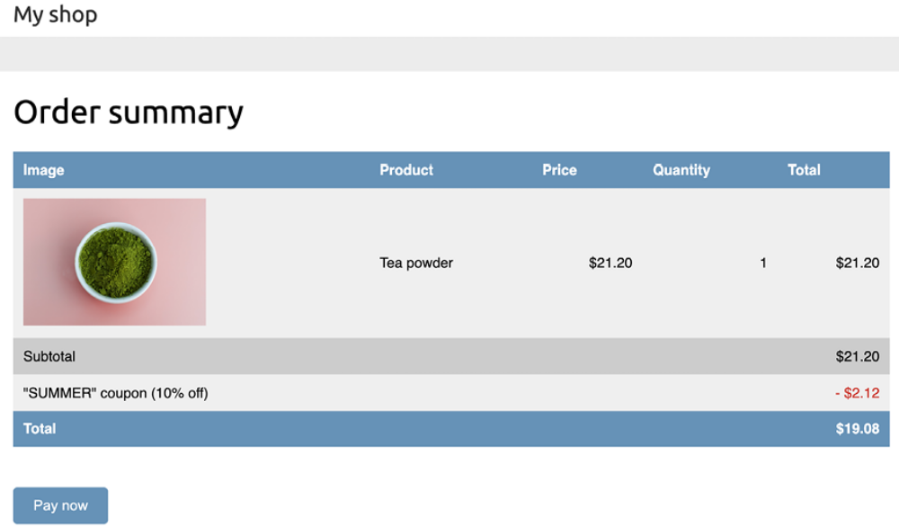
Figure 10.9: The Order summary page, including the coupon applied to the order

If you click on Pay now, you will see that Stripe is not aware of the discount applied, as displayed in Figure 10.10:
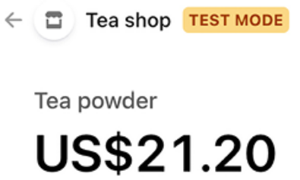
Figure 10.10: The item details of the Stripe Checkout page, including no discount coupon

Stripe shows the full amount to be paid without any deduction. This is because we are not passing on the discount to Stripe. Remember that in the payment_process view, we pass the order items as line_items to Stripe, including the cost and quantity of each order item.

Creating coupons for Stripe Checkout
Stripe allows you to define discount coupons and link them to one-time
payments. You can find more information about creating discounts for Stripe
Checkout athttps://stripe.com/docs/payments/checkout/discounts.
Let’s edit the payment_process view to create a coupon for Stripe Checkout.
Edit the views.py file of the payment application and add the following code highlighted in bold to the payment_process view:
def payment_process(request):
order_id = request.session.get('order_id')
order = get_object_or_404(Order, id=order_id)
if request.method == 'POST':
success_url = request.build_absolute_uri(
reverse('payment:completed')
)
cancel_url = request.build_absolute_uri(
reverse('payment:canceled')
)
# Stripe checkout session data
session_data = {
'mode': 'payment',
'client_reference_id': order.id,
'success_url': success_url,
'cancel_url': cancel_url,
'line_items': []
}
# add order items to the Stripe checkout session
for item in order.items.all():
session_data['line_items'].append(
{
'price_data': {
'unit_amount': int(item.price * Decimal(
'currency': 'usd',
'product_data': {
'name': item.product.name,
},
},
'quantity': item.quantity,
}
)
# Stripe coupon
if order.coupon:
stripe_coupon = stripe.Coupon.create(
name=order.coupon.code,
percent_off=order.discount,
duration='once'
)
session_data['discounts'] = [{'coupon': stripe_coupo
# create Stripe checkout session
session = stripe.checkout.Session.create(**session_data)
# redirect to Stripe payment form
return redirect(session.url, code=303)
else:
return render(request, 'payment/process.html', locals())

In the new code, you check if the order has a related coupon. In that case, you use the Stripe SDK to create a Stripe coupon using
stripe.Coupon.create() . You use the following attributes for the coupon:

- name : The code of the coupon related to the order object is used.

- percent_off : The discount of the order object is issued.

- duration : The value once is used. This indicates to Stripe that this is a coupon for a one-time payment.

After creating the coupon, its id is added to the session_data dictionary used to create the Stripe Checkout session. This links the coupon to the checkout session.

Open http://127.0.0.1:8000/ in your browser and complete a purchase
using the coupon you created. When redirected to the Stripe Checkout page, you will see the coupon applied:
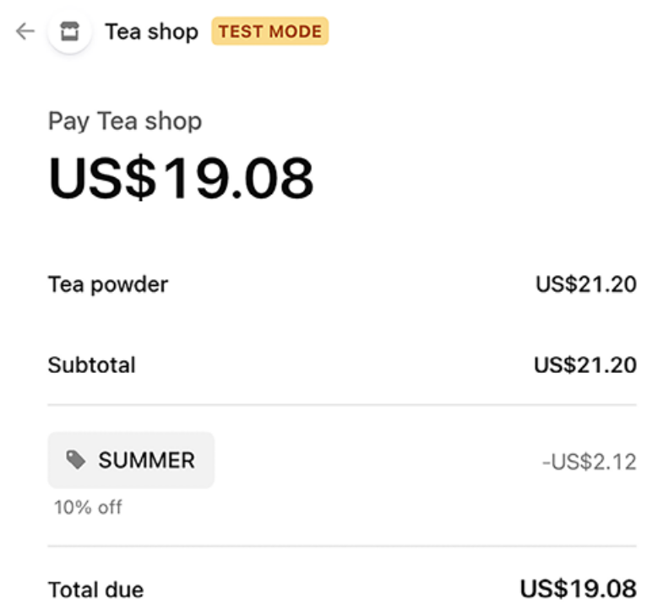
Figure 10.11: The item details of the Stripe Checkout page, including a discount coupon named SUMMER

The Stripe Checkout page now includes the order coupon, and the total amount to pay now includes the amount deducted using the coupon.

Complete the purchase and then open
http://127.0.0.1:8000/admin/orders/order/ in your browser. Click on the order object for which the coupon was used. The edit form will display the discount applied, as shown in Figure 10.12:
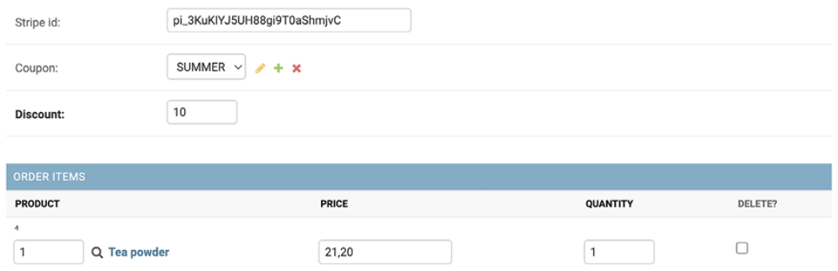
Figure 10.12: The order edit form, including the coupon and discount applied

You have successfully stored coupons for orders and processed payments with discounts. Next, you will add coupons to the order detail view of the administration site and to PDF invoices for orders.

Adding coupons to orders on the administration site and to PDF invoices
Let’s add the coupon to the order detail page on the administration site. Edit
the admin/orders/order/detail.html template of the orders application
and add the following code highlighted in bold:
...
<table style="width:100%">
...
<tbody>
{% for item in order.items.all %}
<tr class="row{% cycle "1" "2" %}">
<td>{{ item.product.name }}</td>
<td class="num">${{ item.price }}</td>
<td class="num">{{ item.quantity }}</td>
<td class="num">${{ item.get_cost }}</td>
</tr>
{% endfor %}
{% if order.coupon %}
<tr class="subtotal">
<td colspan="3">Subtotal</td>
<td class="num">
${{ order.get_total_cost_before_discount|floatformat:2
</td>
</tr>
<tr>
<td colspan="3">
"{{ order.coupon.code }}" coupon
({{ order.discount }}% off)
</td>
<td class="num neg">
- ${{ order.get_discount|floatformat:2 }}
</td>
</tr>
{% endif %}
<tr class="total">
<td colspan="3">Total</td>
<td class="num">
${{ order.get_total_cost|floatformat:2 }}
</td>
</tr>
</tbody>
</table>
...

Access http://127.0.0.1:8000/admin/orders/order/ with your browser, and click on the View link of the latest order. The Items bought table will now include the coupon used, as shown in Figure 10.13:
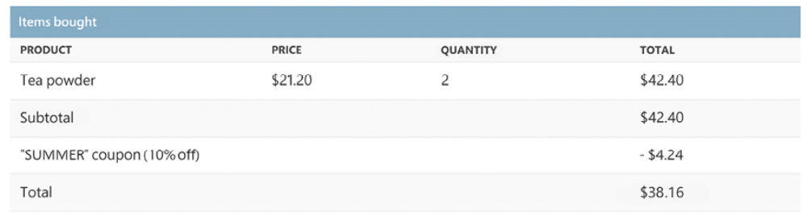
Figure 10.13: The product detail page on the administration site, including the coupon used

Now, let’s modify the order invoice template to include the coupon used for the order. Edit the orders/order/pdf.html template of the orders application and add the following code highlighted in bold:
...
<table>
<thead>
<tr>
<th>Product</th>
<th>Price</th>
<th>Quantity</th>
<th>Cost</th>
</tr>
</thead>
<tbody>
{% for item in order.items.all %}
<tr class="row{% cycle "1" "2" %}">
<td>{{ item.product.name }}</td>
<td class="num">${{ item.price }}</td>
<td class="num">{{ item.quantity }}</td>
<td class="num">${{ item.get_cost }}</td>
</tr>
{% endfor %}
{% if order.coupon %}
<tr class="subtotal">
<td colspan="3">Subtotal</td>
<td class="num">
${{ order.get_total_cost_before_discount|floatformat:2
</td>
</tr>
<tr>
<td colspan="3">
"{{ order.coupon.code }}" coupon
({{ order.discount }}% off)
</td>
<td class="num neg">
- ${{ order.get_discount|floatformat:2 }}
</td>
</tr>
{% endif %}
<tr class="total">
<td colspan="3">Total</td>
<td class="num">${{ order.get_total_cost|floatformat:2 }}</td>
</tr>
</tbody>
</table>
...

Access http://127.0.0.1:8000/admin/orders/order/ with your browser, and click on the PDF link of the latest order. The Items bought table will include the coupon used, as shown in Figure 10.14:
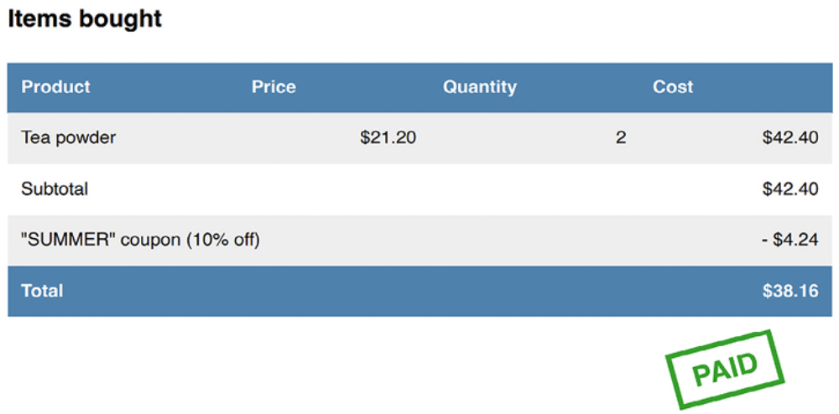
Figure 10.14: The PDF order invoice, including the coupon used
You successfully added a coupon system to your shop. Next, you are going to build a product recommendation engine.
Building a recommendation engine
A recommendation engine is a system that predicts the preference or rating that a user would give to an item. The system selects relevant items for a user based on their behavior and the knowledge it has about them.

Nowadays, recommendation systems are used in many online services. They help users by selecting the stuff they might be interested in from the vast amount of available data that is irrelevant to them. Offering good recommendations enhances user engagement. E-commerce sites also benefit from offering relevant product recommendations by increasing their average revenue per user.

You are going to create a simple yet powerful recommendation engine that suggests products that are usually bought together. You will suggest products based on historical sales, thus identifying products that are usually bought together. You are going to suggest complementary products in two different scenarios:

- Product detail page: You will display a list of products that are usually bought with the given product. This will be displayed as users who bought this also bought X, Y, and Z. You need a data structure that allows you to store the number of times each product has been bought together with the product being displayed.

- Cart detail page: Based on the products that users add to the cart, you are going to suggest products that are usually bought together with these ones. In this case, the score you calculate to obtain related products has to be aggregated.

You are going to use Redis to store products that are usually purchased together. Remember that you already used Redis in Chapter 7, Tracking User Actions. If you haven’t installed Redis yet, you can find installation instructions in that chapter.

Recommending products based on previous purchases
We will recommend products to users based on items that are frequently bought together. For that, we are going to use Redis sorted sets. Remember that you used sorted sets in Chapter 7, Tracking User Actions, to create a ranking of the most viewed images on your site.
Figure 10.15 shows a representation of a sorted set, where set members are strings associated with a score:
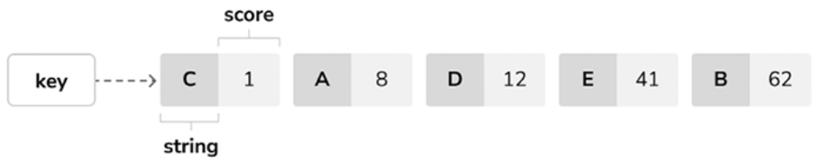
Figure 10.15: Redis sorted set representation

We are going to store a key in Redis for each product bought on the site. The product key will contain a Redis sorted set with scores. Every time a new purchase is completed, we will increment the score by 1 for each product bought together. The sorted set will allow you to give scores to products that are bought together. We will use the number of times the product is bought with another product as the score for that item.

Remember to install redis-py in your environment using the following command:
python -m pip install redis==5.0.4

Edit the settings.py file of your project and add the following settings to it:
# Redis settings
REDIS_HOST = 'localhost'
REDIS_PORT = 6379
REDIS_DB = 1

These are the settings required to establish a connection with the Redis server. Create a new file inside the shop application directory and name it recommender.py . Add the following code to it:
import redis
from django.conf import settings
from .models import Product
# connect to redis
r = redis.Redis(
host=settings.REDIS_HOST,
port=settings.REDIS_PORT,
db=settings.REDIS_DB
)
class Recommender:
def get_product_key(self, id):
return f'product:{id}:purchased_with'
def products_bought(self, products):
product_ids = [p.id for p in products]
for product_id in product_ids:
for with_id in product_ids:
# get the other products bought with each produc
if product_id != with_id:
# increment score for product purchased toge
r.zincrby(
self.get_product_key(product_id), 1, wit
)

This is the Recommender class, which will allow you to store product purchases and retrieve product suggestions for a given product or products.

The get_product_key() method receives the ID of a Product object and builds the Redis key for the sorted set where related products are stored, which looks like product:[id]:purchased_with .

The products_bought() method receives a list of Product objects that have been bought together (that is, belong to the same order).

In this method, you perform the following tasks:

1. You get the product IDs for the given Product objects.

2. You iterate over the product IDs. For each ID, you iterate again over the product IDs and skip the same product so that you get the products that are bought together with each product.

3. You get the Redis product key for each product bought using the get_product_id() method. For a product with an ID of 33 , this method returns the key product:33:purchased_with . This is the key for the sorted set that contains the product IDs of products that were bought together with this one.

4. You increment the score of each product ID contained in the sorted set by 1 using the Redis ZINCRBY operation. The score represents the number of times another product has been bought together with the given product.

Figure 10.16 shows an example of five different products with IDs 1 to 5 and five purchase orders of different combinations of products:
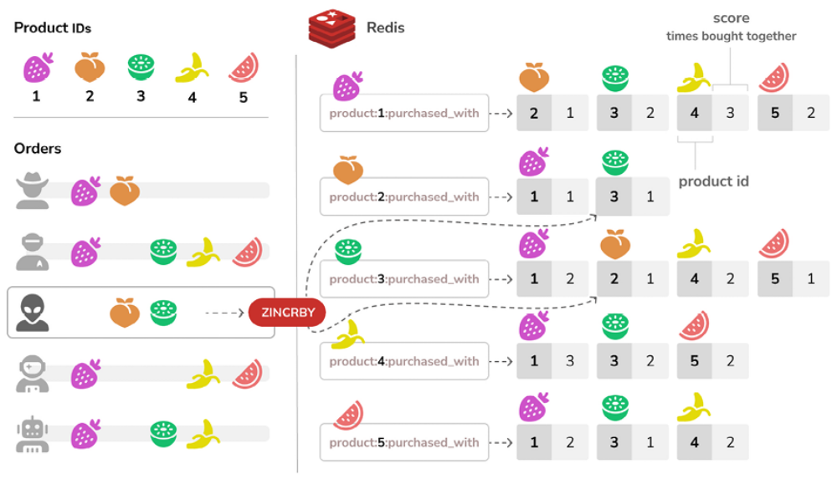
Figure 10.16: Five products with respective IDs and purchase order combinations

In the figure, you can see a sorted set created in Redis for each product, with the key product:<id>:purchased_with , where <id> is the product’s unique identifier. The sorted set members are the IDs of the products that have been purchased alongside the principal product. The score for each member reflects the cumulative count of joint purchases. The figure shows the ZINCRBY Redis operation to increment by 1 the score of products purchased together in one order.

You now have a method to store and score the products that were bought together. Next, you need a method to retrieve the products that were bought together for a list of given products. Add the following suggest_products_for() method to the Recommender class:
def suggest_products_for(self, products, max_results=6):
product_ids = [p.id for p in products]
if len(products) == 1:
# only 1 product
suggestions = r.zrange(
self.get_product_key(product_ids[0]), 0, -1, desc=Tr
)[:max_results]
else:
# generate a temporary key
flat_ids = ''.join([str(id) for id in product_ids])
tmp_key = f'tmp_{flat_ids}'
# multiple products, combine scores of all products
# store the resulting sorted set in a temporary key
keys = [self.get_product_key(id) for id in product_ids]
r.zunionstore(tmp_key, keys)
# remove ids for the products the recommendation is for
r.zrem(tmp_key, *product_ids)
# get the product ids by their score, descendant sort
suggestions = r.zrange(
tmp_key, 0, -1, desc=True
)[:max_results]
# remove the temporary key
r.delete(tmp_key)
suggested_products_ids = [int(id) for id in suggestions]
# get suggested products and sort by order of appearance
suggested_products = list(
Product.objects.filter(id__in=suggested_products_ids)
)
suggested_products.sort(
key=lambda x: suggested_products_ids.index(x.id)
)
return suggested_products

The suggest_products_for() method receives the following parameters:

- products : This is a list of Product objects to get recommendations for. It can contain one or more products.

- max_results : This is an integer that represents the maximum number of recommendations to return.

In this method, you perform the following actions:

1. You get the product IDs for the given Product objects.

2. If only one product is given, you retrieve the ID of the products that were bought together with the given product, ordered by the total number of times that they were bought together. To do so, you use Redis’ ZRANGE command. You limit the number of results to the number specified in the max_results attribute (6 by default). You can read
more about the ZRANGE command at https://redis.io/commands/zrange/.

3. If more than one product is given, you generate a temporary Redis key built with the IDs of the products.

4. Combine and sum all scores for the items contained in the sorted set of each of the given products. This is done using the Redis ZUNIONSTORE command. The ZUNIONSTORE command performs a union of the sorted sets with the given keys and stores the aggregated sum of scores of the elements in a new Redis key. You can read more about this command at https://redis.io/commands/zunionstore/. You save the
aggregated scores in the temporary key.

5. Since you are aggregating scores, you might obtain the same products you are getting recommendations for. You remove them from the generated sorted set using the ZREM command. You can read more about the ZREM command at https://redis.io/commands/zrem/.

6. You retrieve the IDs of the products from the temporary key, ordered by their scores using the ZRANGE command. You limit the number of results to the number specified in the max_results attribute.

7. Then, you remove the temporary key using the redis-py delete() method that executes the Redis DEL command. You can read more about the DEL command at
https://redis.io/commands/del/.

8. Finally, you get the Product objects with the given IDs, and you order the products in the same order as the sorted set members.

Figure 10.17 shows an example of a session where two products have been added to the shopping cart and the Redis operations performed to obtain related product recommendations:
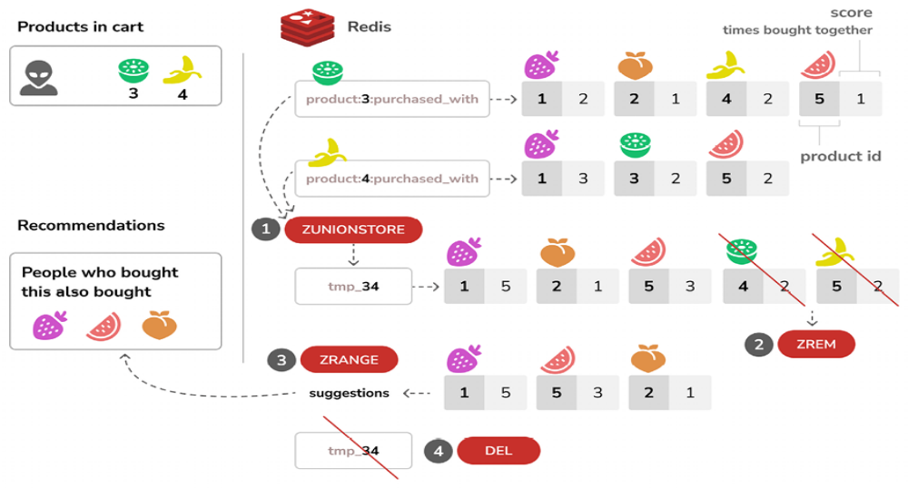
Figure 10.17: Product recommendation system
In the figure, you can see the four steps to generate product recommendations for the items in the cart:

1. The ZUNIONSTORE Redis command is used to aggregate the scores of products purchased frequently with the products in the shopping cart. The resulting sorted set of this operation is stored in a new Redis key named after the IDs of the products in the shopping cart, tmp_34 for IDs 3 and 4 .

2. The ZREM command is used to remove the products being purchased from the sorted set, to avoid recommending products that are already in the shopping cart.

3. The ZRANGE command is used to return the tmp_34 sorted set members ordered by score.

4. Finally, the DEL command is used to delete the Redis key tmp_34 .

For practical purposes, let’s also add a method to clear the recommendations.
Add the following method to the Recommender class:
def clear_purchases(self):
for id in Product.objects.values_list('id', flat=True):
r.delete(self.get_product_key(id))

Let’s try the recommendation engine. Make sure you include several Product objects in the database and initialize the Redis Docker container using the following command:
docker run -it --rm --name redis -p 6379:6379 redis:7.2.4

Open another shell and run the following command to open the Python shell:
python manage.py shell

Make sure that you have at least four different products in your database.
Retrieve four different products by their names:
>>> from shop.models import Product
>>> black_tea = Product.objects.get(name='Black tea')
>>> red_tea = Product.objects.get(name='Red tea')
>>> green_tea = Product.objects.get(name='Green tea')
>>> tea_powder = Product.objects.get(name='Tea powder')

Then, add some test purchases to the recommendation engine:
>>> from shop.recommender import Recommender
>>> r = Recommender()
>>> r.products_bought([black_tea, red_tea])
>>> r.products_bought([black_tea, green_tea])
>>> r.products_bought([red_tea, black_tea, tea_powder])
>>> r.products_bought([green_tea, tea_powder])
>>> r.products_bought([black_tea, tea_powder])
>>> r.products_bought([red_tea, green_tea])

You have stored the following scores:
black_tea: red_tea (2), tea_powder (2), green_tea (1)
red_tea: black_tea (2), tea_powder (1), green_tea (1)
green_tea: black_tea (1), tea_powder (1), red_tea(1)
tea_powder: black_tea (2), red_tea (1), green_tea (1)

This is a representation of products that have been bought together with each of the products, including how many times they have been bought together.
Let’s retrieve product recommendations for a single product:
>>> r.suggest_products_for([black_tea])
[<Product: Tea powder>, <Product: Red tea>, <Product: Green tea>]
>>> r.suggest_products_for([red_tea])
[<Product: Black tea>, <Product: Tea powder>, <Product: Green tea
>>> r.suggest_products_for([green_tea])
[<Product: Black tea>, <Product: Tea powder>, <Product: Red tea>]
>>> r.suggest_products_for([tea_powder])
[<Product: Black tea>, <Product: Red tea>, <Product: Green tea>]

You can see that the order for recommended products is based on their score.
Let’s get recommendations for multiple products with aggregated scores:
>>> r.suggest_products_for([black_tea, red_tea])
[<Product: Tea powder>, <Product: Green tea>]
>>> r.suggest_products_for([green_tea, red_tea])
[<Product: Black tea>, <Product: Tea powder>]
>>> r.suggest_products_for([tea_powder, black_tea])
[<Product: Red tea>, <Product: Green tea>]

You can see that the order of the suggested products matches the aggregated scores. For example, products suggested for black_tea and red_tea are tea_powder (2+1 ) and green_tea (1+1 ).

You have verified that your recommendation algorithm works as expected.

Let’s store the products that are bought together every time a payment is confirmed. Edit the webhooks.py file of the payment application and add the following code highlighted in bold:
# ...
from shop.models import Product
from shop.recommender import Recommender
@csrf_exempt
def stripe_webhook(request):
# ...
if event.type == 'checkout.session.completed':
session = event.data.object
if (
session.mode == 'payment'
and session.payment_status == 'paid'
):
try:
order = Order.objects.get(
id=session.client_reference_id
)
except Order.DoesNotExist:
return HttpResponse(status=404)
# mark order as paid
order.paid = True
# store Stripe payment ID
order.stripe_id = session.payment_intent
order.save()
# save items bought for product recommendations
product_ids = order.items.values_list('product_id')
products = Product.objects.filter(id__in=product_ids
r = Recommender()
r.products_bought(products)
# launch asynchronous task
payment_completed.delay(order.id)
return HttpResponse(status=200)

In the new code, when a new order payment is confirmed, you retrieve the Product objects associated with the order items. Then, you create an instance of the Recommender class and call the products_bought() method to store the products bought together in Redis.

You are now storing the related products that are bought together when orders are paid. Let’s now display recommendations for products on your site.

Edit the views.py file of the shop application. Add the functionality to retrieve a maximum of four recommended products into the product_detail view, as follows:
from .recommender import Recommender
def product_detail(request, id, slug):
product = get_object_or_404(
Product, id=id, slug=slug, available=True
)
cart_product_form = CartAddProductForm()
r = Recommender()
recommended_products = r.suggest_products_for([product], 4)
return render(
request,
'shop/product/detail.html',
{
'product': product,
'cart_product_form': cart_product_form,
'recommended_products': recommended_products
}
)

Edit the shop/product/detail.html template of the shop application and
add the following code after {{ product.description|linebreaks }} :
{% if recommended_products %}
<div class="recommendations">
<h3>People who bought this also bought</h3>
{% for p in recommended_products %}
<div class="item">
<a href="{{ p.get_absolute_url }}">
<img src="{% if p.image %}{{ p.image.url }}{% else %}
{% static "img/no_image.png" %}{% endif %}">
</a>
<p><a href="{{ p.get_absolute_url }}">{{ p.name }}</a></p>
</div>
{% endfor %}
</div>
{% endif %}

Run the development server, and open http://127.0.0.1:8000/ in your browser. Click on any product to view its details. You should see that recommended products are displayed below the product, as shown in Figure 10.18:
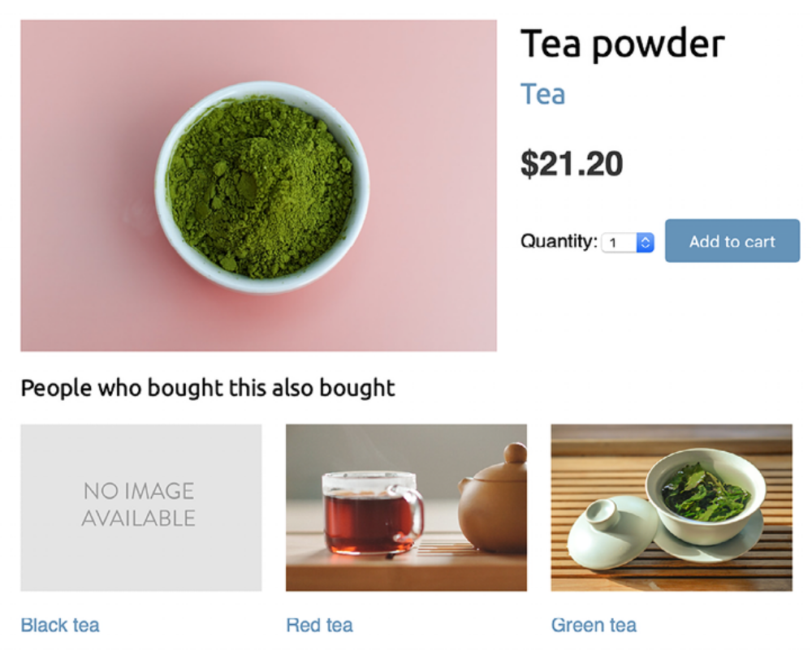
Figure 10.18: The product detail page, including recommended products

Images in this chapter:

- Green tea: Photo by Jia Ye on Unsplash
- Red tea: Photo by Manki Kim on Unsplash
- Tea powder: Photo by Phuong Nguyen on Unsplash

You are also going to include product recommendations in the cart. The recommendations will be based on the products that the user has added to the cart.

Edit views.py inside the cart application, import the Recommender class, and edit the cart_detail view to make it look like the following:
from shop.recommender import Recommender
def cart_detail(request):
cart = Cart(request)
for item in cart:
item['update_quantity_form'] = CartAddProductForm(
initial={'quantity': item['quantity'], 'override': T
)
coupon_apply_form = CouponApplyForm()
r = Recommender()
cart_products = [item['product'] for item in cart]
if(cart_products):
recommended_products = r.suggest_products_for(
cart_products, max_results=4
)
else:
recommended_products = []
return render(
request,
'cart/detail.html',
{
'cart': cart,
'coupon_apply_form': coupon_apply_form,
'recommended_products': recommended_products})
}
)

Edit the cart/detail.html template of the cart application and add the following code just after the </table> HTML tag:
{% if recommended_products %}
<div class="recommendations cart">
<h3>People who bought this also bought</h3>
{% for p in recommended_products %}
<div class="item">
<a href="{{ p.get_absolute_url }}">
<img src="{% if p.image %}{{ p.image.url }}{% else %}
{% static "img/no_image.png" %}{% endif %}">
</a>
<p><a href="{{ p.get_absolute_url }}">{{ p.name }}</a></p>
</div>
{% endfor %}
</div>
{% endif %}

Open http://127.0.0.1:8000/en/ in your browser and add a couple of products to your cart. When you navigate to http://127.0.0.1:8000/en/cart/ , you should see the aggregated product
recommendations for the items in the cart, as follows:
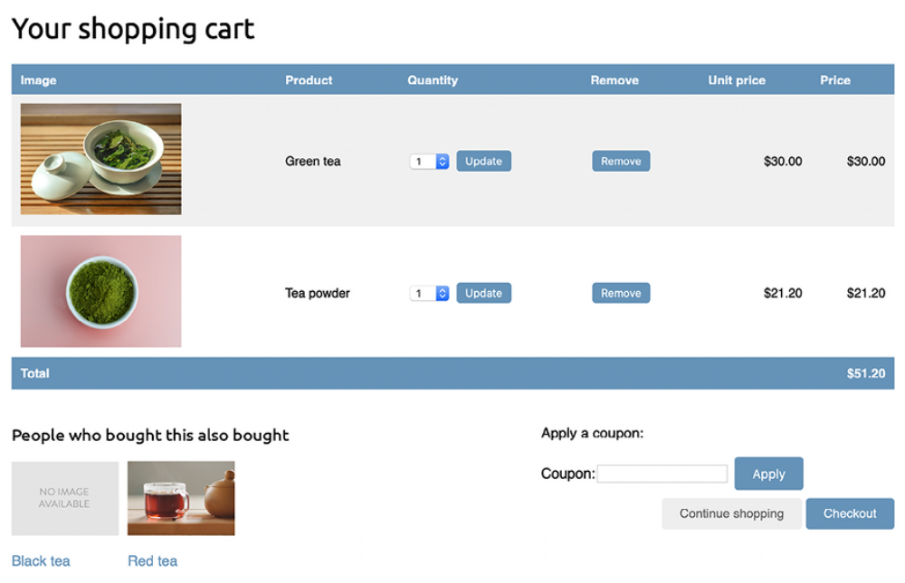
Figure 10.19: The shopping cart details page, including recommended products

Congratulations! You have built a complete recommendation engine using Django and Redis.

Summary
In this chapter, you created a coupon system using Django sessions and integrated it with Stripe. You also built a recommendation engine using Redis to recommend products that are usually purchased together.

The next chapter will give you an insight into the internationalization and localization of Django projects. You will learn how to translate code and manage translations with Rosetta. You will implement URLs for translations and build a language selector. You will also implement model translations using django-parler and you will validate localized form fields using django-localflavor .

Additional resources
The following resources provide additional information related to the topics
covered in this chapter:
Source code for this chapter: ( See page 745 )

